1. Start SSMS.
Click All Programs\ Microsoft SQL Server 2012\ SQL Server Management Studio
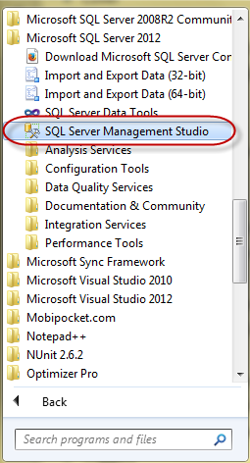

2. Connect to Server

- Choose Server type as Database Engine
- Choose Authentication as Windows Authentication or SQL Server Authenticatione
- Then click Connect
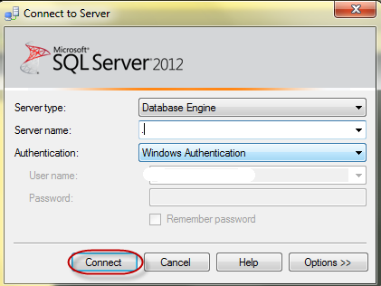

3. Query Editor

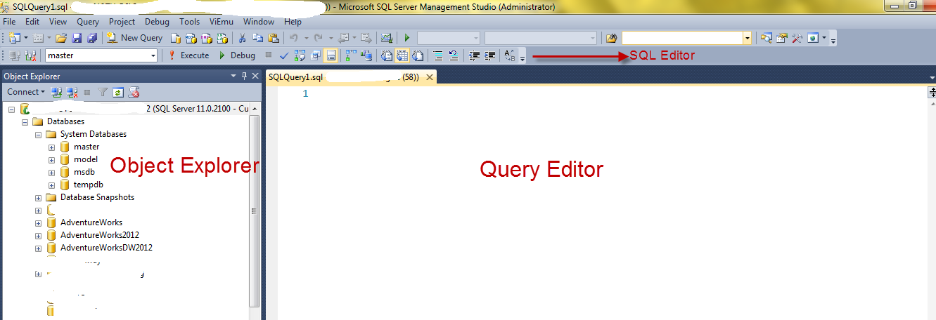

Object Explorer: Manage database objects.
- master database: Stores system-level information
- model database: Is used as the template for all database. When a database is created, SQL Server copy the contents of the model database to the new database
- msdb database: Is used by SQL Server Agent for scheduling jobs.
- temp database: Is used to hold temporary objects...For instance, in SSMS enters:
create table #temp (Id int)

run this under AdventureWorks database. Then, go to tempdb database, this table is hold in Temporary Tables

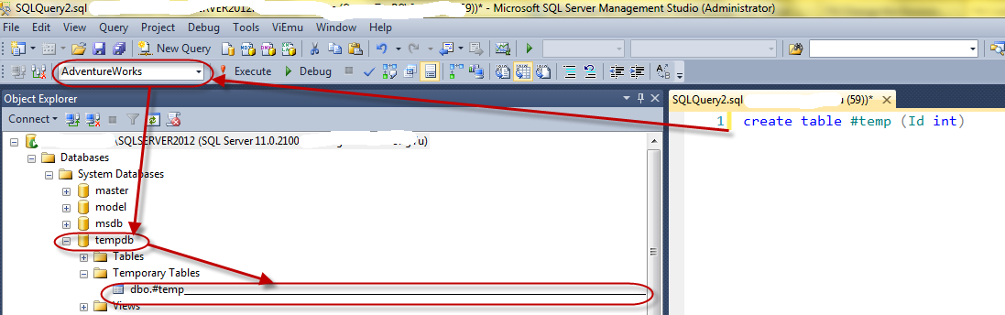

4. Debug in SSMS

SQL Server from 2005 version and above support Debug feature like Visual Studio. In SSMS, click Debug button.
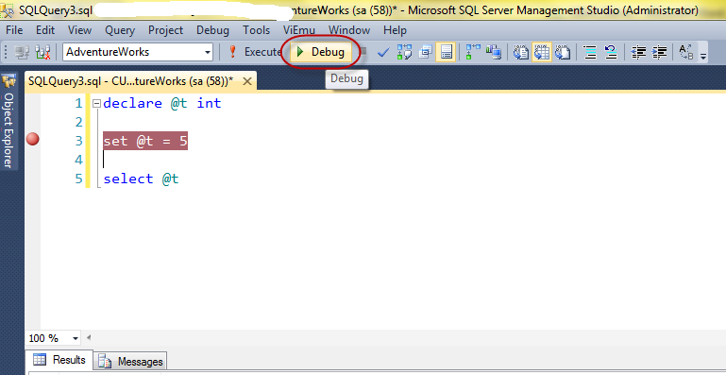
Then, we can see QuickWatch window just like Visual Studio.
